Harnessing Maize Science and Innovation for Improving Food Security in Indo-Pacific
Concept Summary
With an investment of USD 900,000, this activity will strengthen Nepal’s maize value chains by strengthening the maize commercial model (MCM) which is designed around CIMMYTs MasAgro (Sustainable Modernization of Traditional Agriculture) model by delineating specific hubs for spring maize production in Nepal’s terai. While maize demand is increasing, the biotic and abiotic stresses impact production and market systems affecting sub-sector growth. Through targeted interventions, CIMMYT and its partners have contributed to strengthening maize hybrid seed industry, collaborative breeding, public–private seed system partnerships, all-encompassing digital seed innovations, increasing commercial maize production with tested and validated socio-technology bundles, facilitating stronger market linkages, and enhancing the resilience of agribusiness MSMEs, lay the foundation for a sustainable, market-driven maize seed system, capable of delivering high-quality seed at scale. These efforts align with the Government of Nepal’s (GoN) Agriculture Development Strategy (ADS) objectives, which focus on fostering maize value chain development.
The MasAgro model fosters collaboration and integration among stakeholders at the federal, provincial and local level in the maize and associated crops value chains to co-develop, locally validate and disseminate best-bet recommendations and technologies for accelerated adoption of sustainable farming solutions in target ecological zones. The MasAgro model, which has been endorsed by the GoN, is more relevant currently as Nepal stands on the verge of graduating to the category to developing country, from November 2026.
The primary goal of MasAgro in Nepal will be to strengthen the foundation of maize science and research, technology dissemination, post-harvest management, market development and digital technology. The activity will translate knowledge into scalable pathways and investment options while strengthening farmers livelihoods, responsible business models and national and regional maize supply chains to contribute to national maize self-sufficiency. The GoN and private sector will be supported to focus on in-country resource mobilization in collaboration with bilateral and multilateral agencies, facilitate structural reforms and develop human capital among others.
Problem Summary
Despite maize being Nepal’s second most important staple crop, productivity remains low and yield stability is increasingly threatened by climate variability, weak varietal pipelines, and underdeveloped seed delivery systems. There is a wide gap between the actual and potential yields of maize at the farm level. A large part of this gap is a result of unorganized and inefficient input markets (seed, fertilizer, mechanization, irrigation). Domestic seed production capacity is inadequate, small, and insufficient to meet these requirements. Timely access to quality seed with locally relevant genetic traits (e.g., high yield potential, resilience to biotic and abiotic stresses, processing for food and feed), fragmented breeding–seed sector linkages, low investment in early-generation seed production, weak quality assurance is a gap in Nepal. As a result, seed replacement rates remain below 20 percent, the domestic hybrid seed industry is underdeveloped, and farmers remain heavily dependent on informal seed sources and imports. Without systemic interventions that address both supply- and demand-side bottlenecks, Nepal’s maize sector will continue to face persistent productivity gaps, and growing vulnerability to climate stress. This situation coupled with poor availability and high prices of fertilizer pose binding constraints to improving agricultural productivity and rural livelihoods in Nepal. Additionally, input market actors face low capacity and poor market development constraints to scale their business to tap unmet demand.
In Nepal, maize plays a critical role in food security and as a key input for the growing poultry and feed industry. The demand for maize for ethanol production will also increase in near future. However, inefficiencies in production, inconsistent supply chains, and limited market access hinder growth. Similarly, agribusiness micro small and medium (MSMEs) face challenges such as limited access to finance, supply chain disruptions, and inadequate market intelligence.
At the same time, fluctuating global maize supplies, fragmented domestic supply chains, and limited market integration – worsened by weak maize-sector infrastructure and weather-related risks - amplify price and availability shocks, fueling market volatility and disrupting trade. As a result, food, fodder, feed processors, and other maize‑based industries struggle to secure a sustainable and reliable maize supply.
Proposed solutions
CIMMYT and its partners are promoting a ‘maize commercial model (MCM)’ in Nepal since 2021. The MCM is designed around CIMMYTs MasAgro (Sustainable Modernization of Traditional Agriculture) model which is being implemented together with the Government of Mexico. At its foundation, the MasAgro initiative follows a systems approach with a hub model to address the needs of the local production systems and its actors, and as such, achieve higher and more stable yields, increase farmer income, and promote sustainable natural resource management in agriculture. It fosters collaboration and integration among stakeholders at the federal, provincial and local level in the maize, wheat, and associated crops value chains to co-develop, locally validate and disseminate best-bet recommendations and technologies for accelerated adoption of sustainable farming solutions in target ecological zones. The hub model is being replicated in Nepal with the Ministry of Agriculture and Livestock Development (MoALD).
The MCM through the Nepal Hub approach leverages public-private partnership (PPP) to modernize traditional maize production and market systems. MCM fosters collaboration and partnerships with public and private agencies to introduce maize in spring fallows after rice harvest to diversify cropping systems with new profitable maize for meeting food and livelihood needs of farmers with efficient market linkages. This approach integrates smallholder farmers into structured maize value chains by providing them with improved production and post-harvest technologies, linking them to buyers, and fostering investments in the maize sector with public private partnerships (See conceptual framework fig in Annex 1).
Starting with 4 districts in 2021, the MCM was implemented on approximately 2,000 ha covering 9 districts and 29 rural municipalities in Nepal’s Western Terai in 2025. From 2021 to 2025, spring maize adoption in Western Terai soared by 700%, over 2021 figures and maize productivity doubled compared to national average. There was a 75% increase in the farm gate price of maize since 2021.
In 2025, CIMMYT MCM scaling assessment with stakeholders using the scaling scan tool (www.scalingscan.org) showed that the MCM could be scaled to 44,000 hac with a potential to benefit 175,000 households over the next 5 years. The scaling potential of spring maize is estimated to be 32,000 ha in Eastern Terai. Looking at the potential, the MoALD allocated USD 73,000 in financial year 2025-26 to scale the MCM from Western to Eastern Nepal and to build the capacity of 6 municipalities in West and East Nepal to scale the MCM in their respective regions.
This MasAgro modelled project will contribute to the scaling ambition and will further strengthen and scale pathways to sustainable and resilient maize production and market system development by developing two agro ecologically distinct hubs, one each in Western and Eastern Nepal, to foster and strengthen science based transdisciplinary partnerships to meet Nepal’s increasing maize requirement.
The project will adopt an integrated seed systems, agronomy and maize market development approach to rapidly strengthen Nepal’s maize seed and grain sector through strategically selected innovation hubs. Building on CIMMYT’s proven success in Nepal, the project will combine accelerated varietal deployment, local hybrid seed production, and private-sector capacity development to address persistent bottlenecks in seed availability, affordability, and quality. The project will upgrade networks of value chain actors and strengthen extension systems by building partnerships that enable them to disseminate available promising socio-technical bundles. The project will address site specificities and recommend/update policy and program frameworks by utilizing impact evidence to promote growth of agriculture input and output markets in selected hubs.
Alignment with CIMMYT 2030 strategy
By integrating GMP-SAS-GEYSI-MELIA-Data colleagues engaged in breeding, seed systems, agronomy, and market development, the proposal directly contributes to CIMMYTs mission of “science and innovation for a food and nutrition secure world” and aligns with primary objectives 3, 4 and 5. The theory of change links the axes of discovery -> system dev -> CIMMYT Inc, leading to transformational shift from fragmented technology adoption to an integrated ecosystem that support scaling and sustainability.

Value proposition and future proofing

- Resilient Maize Ecosystems: Building resilient maize ecosystems will enable maize sector stakeholders to develop strategic pathways for sustainable maize production and market systems, implement risk mitigation solutions and improve supply chains in the country and beyond. The work will elucidate information on maize market trends and emerging supply chains which will be valuable for public and private actors to take business and investment decisions, establish well-functioning supply chains and ensure maize market stability. These will support policy development and increased investment in the maize sector.
- Contribution to national maize production stability: By improving farm productivity, reducing yield variability, and strengthening market coordination in Nepal, the proposed work contributes to dampening price volatility and supporting more predictable global maize markets. With rapid urbanization, demand is rising for maize grain and biomass feed to sustain livestock production and supply nutritious foods such as milk, eggs and meat. With Nepal’s recent decision to blend up to 10% ethanol into imported petrol, the demand for maize in Nepal will increase in near future which is a great opportunity of maize breeding and commercial production.
- Food security, resilience, and reduced downstream instability risks: Strengthening maize-based agri-food systems improves resilience, stabilizes rural livelihoods, and reduces the risk of stress-driven economic disruption. This aligns with national and U.S. interests in promoting stable, resilient food systems in strategically important regions of the Indo-Pacific. Recently, Nepal witnessed youth unrest related to poor governance and limited job opportunities. These pressures can amplify broader economic and social instability over time.
- Transdisciplinary approaches to Garner Investments in Maize sector: The emerging opportunities in maize food, feed, biofuel and its integration with livestock sector will attract huge investments from public and private sectors in maize agrifood systems. This will in turn demand research evidence on improved varieties, breeds, agronomy, post-harvest and resilient supply chains. The initial AURORA investments will build transdisciplinary approaches in maize sector development by integrating science, policy, private sector, and farmer knowledge to co-create scalable, market-aligned, and climate-resilient solutions that will be linked to the funding priorities of multilateral and bi-lateral funding agencies.
Work Package 1:
Integrated maize breeding and seed systems
The MasAgro Nepal framework intends to accelerate the development and deployment of high yielding, stress tolerant, early maturing hybrid varieties (approx.100 days in spring season) and hybrids that meet the requirements of consumers food, feed and ethanol industries. The project will facilitate access to elite germplasm from CGIAR and other international agencies for NARC and Nepali seed companies. Seed companies that received variety development and maintenance license will be capacitated for accessing germplasm from local and international sources, hybrid variety development and their registration. The new market ready products and locally developed varieties will be evaluated through NARC and private seed companies' networks in the potential MCM market segments following the recent variety development guideline developed by Seed Quality Control Centre (SQCC). Following a public private partnership approach, variety performance data generated by public and private actors will be utilized through data sharing for fast-track variety release and registration process.
The CIMMYT-Nepalgunj seed production and dispatching hub, which is being operated in collaboration with NARC, will serve as a strategic platform to strengthen breeder, pre-basic, and foundation seed supply for maize and other priority cereals, addressing a critical bottleneck in national and regional seed systems.

Work Package 1 Elements:

- Develop climate-similarity maps and define market-led product profiles to guide the targeted development, deployment, and delivery of stress-resilient hybrid maize technologies in priority agro-ecologies.
- Conduct on-farm participatory testing and validation of candidate hybrids with women, men, and youth farmers as part of the formal pre-release evaluation and product advancement process.
- Build the technical and managerial capacity of seed companies to ensure compliant hybrid seed production, quality assurance, certification, and sustainable seed business management.
- Establish or strengthen a coordinated public–private varietal testing and release platform to accelerate evidence-based decision making and varietal deployment.
- Establish localized seed business incubation and hybrid seed production platforms through structured hub-based public–private partnerships (PPPs) to enhance quality seed delivery.
- Promote the digitally enabled seed information system (DESIS) for hybrid variety tracking, EGS production planning, and demand–supply forecasting.
- Develop a national hybrid maize seed roadmap aligned with the MCM scaling vision, in collaboration with NARS and private seed companies, emphasizing domestic hybrid seed production.
- Upgrade CIMMYT’s Nepalgunj Seed Hub with modern cold storage, irrigation, and EGS handling facilities to scale the production of stress-resilient hybrid EGS for Nepal and the region, while generating a sustainable revenue stream to support CIMMYT Inc.

Outputs

- Climate similarity maps and market-aligned product profiles developed and validated, guiding the targeted breeding advancement, testing, and deployment of stress-resilient hybrid maize varieties across priority agro-ecologies in Nepal.
- 15–20 demonstration and validation sites established across selected hubs for participatory evaluation of climate-resilient hybrid maize varieties.
- At least two climate-resilient (“weatherproof”) hybrid maize varieties identified for licensing and advanced toward registration and commercialization.
- Strengthened seed quality assurance network, linking SQCC, regional seed testing laboratories, and seed producers to improve compliance, certification efficiency, and seed reliability at hub level.
- Nepal Coordinated Maize Evaluation Network (NCMEN) established as a national public–private varietal testing platform.
- A national orientation and technical capacity-building workshop conducted on DESIS, with stakeholders trained in digital seed tracking and EGS demand–supply forecasting.
- National hybrid maize seed roadmap endorsed, outlining a phased pathway toward increased domestic hybrid seed production and market expansion.
- CIMMYT Nepalgunj Seed Hub upgraded with cold storage chambers, irrigation infrastructure, and enhanced EGS handling and dispatch facilities.

Work Package 2:
Agronomy and hub scoping work
This work package will tackle the threats arising from changing production contexts by direct engagement with maize farmers, efficient seed delivery, supporting and monitoring crop production, and localized agronomy advisories. On-farm and on-station research will be carried out across hubs to develop effective Integrated Soil Fertility Management (ISFM) strategies, assessing the potential of improved varieties, seed priming, planting time, spacing, weed control, fertilizer and irrigation management and pest & disease management enhancing crop yields. Technologies that enhance water use efficiency (WUE) and nutrient use efficiency (NUE) to improve yields and crop resilience will be packaged.
The project will facilitate testing of new scale appropriate machines and tools that enhance labor use efficiency, are GEYSI friendly, improve product quality, support crop diversification, and scale agronomic practices in on-station and on-farm conditions in collaboration with private sector and National Agriculture Machinery Research Centre (NAMEA). Additionally research evidence will be valuable to attract new business investments in input markets such as seeds, machinery, and soil amendments.
Work Package 2 Elements:
  - Conduct Nepal MasAgro maize hub maize scoping assessment using Integrated Agrifood System Initiative (IASI) tool.
  - Strengthen the structure and design of the hub platforms, farmer modules, extension areas, multi stakeholder platforms and market segments for establishing hub model.
  - Launch the two hubs in Western and Eastern terai in collaboration with the MoALD, NARC and other public and private actors
  - Support commercial maize production in 14000 ha with 19,000 households, 7 seed companies, 72 maize producing cooperatives, 28 agrodealers & 21 local governments
  - Test and validate innovative technologies such as precision/pneumatic planters, zero tillage, intercropping, farm machinery etc for incorporating in national level maize extension system
  - Provide viable solutions for maize postharvest management and value addition by piloting potential solutions related to threshing, drying, grain storage and silage.
  - Implement CIMMYTs e-agrology digital platform for monitoring maize production, assessing cost benefits in two pilot sites of Nepal.
  - Establish hub-anchored digital decision-support platforms with ag-tech companies and extension systems to generate zone-specific field-refined climate-smart and precision agriculture recommendations (soil fertility, planting windows, input rates, and risk alerts) and deliver them at scale across maize zones.
  - Develop a GEYSI action plan and use these to impart soft skills training for extension workers and women- and youth-led agricultural MSMEs focusing on empowerment, entrepreneurial skills and all-encompassing participation.
Outputs
2.1 A strategic roadmap for effective implementation of the hub model established with public and private sector stakeholders
2.2 Two hubs in Western and Eastern Nepal established with functional management and governance structures with a focus on maize and wheat
2.3 About 20,000 women, men, and young farmers, in proportions reflective of their population sizes, benefit from improved maize production technologies and market development.
2.5 Localized production system recommendations integrated with national priorities endorsed for each hub.
2.6 Package of practices for maize postharvest management and value addition piloted and recommendations for use by farmers groups and micro small and medium enterprises prepared
2.7 Digital platforms for monitoring hub level innovation use and application of precision technologies tested and implementation modalities finalized with stakeholders.
Implementation Approach
This activity will be jointly implemented by SAS, GMP and Data programs supported by GEYSI, Comms, MELIA and DFS by forming an interdisciplinary team across the work packages. The above work packages will be carried out in collaboration with national NARES, federal & state (national/sub-national) agricultural ministries, private seed companies, fertilizer dealers, ag tech companies, farmers institutions, market research institutions and business membership institutions.

Communication Plan
Comms will design policy briefs, outreach bundles, and targeted communication products that package technical results, implementation lessons, and risk-reduction benefits for policymakers, extension systems, and private-sector partners to be disseminated in social media, television and national newspapers.

Data
The digital innovation activities proposed are aligned with the CIMMYT Data policies and frameworks which will ensure consistency across projects and alignment with institutional data principles and digital priorities. The e‑Agrology platform will provide real-time, field-level data streams that directly strengthen MELIA tracking, learning and adaptive management.

Monitoring, Evaluation, Learning and Impact Assessment (MELIA)
CIMMYT’s MELIA will support to ensure consistency across projects and alignment with institutional priorities. The approach will be implemented in coordination with other CIMMYT initiatives and aligned with the institutional MELIA framework that CIMMYT is establishing. As this framework is consolidated, indicators and reporting will be harmonized across projects to support learning and comparability at portfolio level. The MELIA approach focuses on tracking delivery, learning, and contribution to outcomes, rather than attributing long-term food security impacts within a single project.

DFS Role
DFS will support in drafting quality concept notes for liaising with ACIAR, JICA and KOICA to establish joint research and development strategies.

Budget
To be added

Unlocking Future Funding
The project will generate funding as per the strategies below.

Funding Idea | Likely Donor | Time frame | Estimated Value (USD)
Submit an invited proposal to scale proven CIMMYT technologies and deepen Indo-Nepal research and knowledge sharing under the MasAgro for Nepal project. | Embassy of India in Nepal | March 2026 proposal submitted; grant anticipated in September 2026 | $ 5 M
Follow up with the proposal on Knowledge Transfer for Climate smart Farming System Development | Asian Development Bank, Nepal | Proposal submitted in March 2025; results of evaluation anticipated in April-May 2026 | USD 1.8 M
Leverage existing relationships with donors to secure joint funding for larger investments into cropping system diversification, seed, and market development. | KOICA  JICA  ACIAR  Regional Governments in Bangladesh, Bhutan, India, Nepal. | Initial discussions in March-April 2026; report and proposal submitted June 2026; grant anticipated in Q4 2026 | $5-8 M
Cross Program Engagement (not including operational and indirect costs)
Program / Unit | Key Contributions
SAS | Lead implementation of the hub networks and location specific good agronomy practices, disseminate proven technologies; quantify value chains and investment roadmaps; develop evidence-based policy information and refine digital agriculture platforms, advisories and capacity development.
GMP | Make available resilient and weather-proofed hybrids; strengthen localized seed systems; digital seed information systems and strengthen the regional early generation hybrid seed testing and dissemination facility.
GEYSI | Broader participation of women, men and youth for equitable and responsible research for development.
Data | Responsible data use, sharing and innovation to enable evidence‑based decisions. (budget exclusive FTE)
DFS, comms, MELIA | Develop policy briefs, outreach bundles, and targeted communication products for farmers, policymakers, extension systems, and private-sector partners using social and traditional media  Track delivery, learning, and contribution to outcomes to demonstrate progress and impacts, and to quantify the value o f this investment in the region  Support donor intelligence and liaison and in drafting concept notes for ACIAR, JICA and KOICA and other donors.

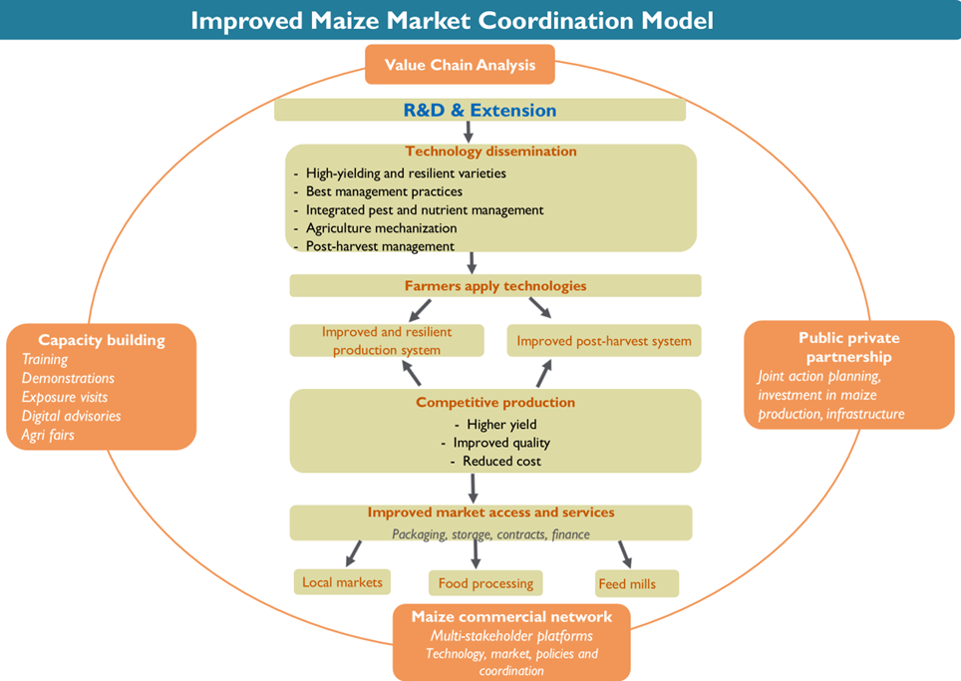
Annex 1: Conceptual framework for MasAgro Nepal Maize

